**Assignment – II**

Use Assignment – I application.

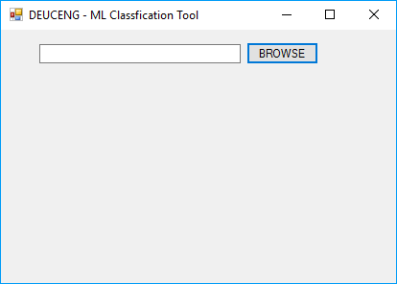

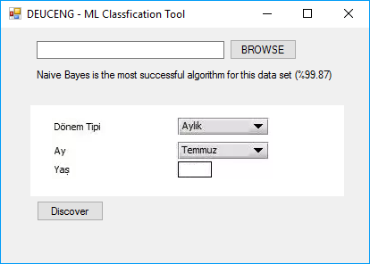

Create dropdownlists or/and textboxes according to nominal and numeric values. You can use grid component for this interface.

In this example dataset, there are 4 attributes as

“Dönem Tipi {Günlük, Aylık, Yıllık}”

“Ay {Ocak, Subat, Mart, ....,Aralık}”

“Yaş is numeric”

Class {A, B, C}

Therefore, “Dönem Tipi” and “Ay” attributes have been created as dropdownlist with sub-fields whereas “Yaş” attribute has been created as a textbox.

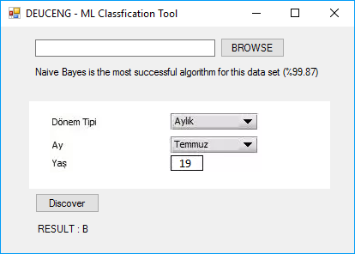

After pushing “Discover”, the class of the new instance is obtained as “B” according to Naive Bayes which has been found as the most successful algorithm for this dataset previously.